What-A-Book

TECHNICAL DESIGN DOCUMENT

|  |  |
| --- | --- |
| **Author** | *House Slytherin* |
| **Last Updated** | 12/4/2022 11:30 AM |
| **Version Number** | *3.0.0* |

**Version History**

|  |  |  |  |
| --- | --- | --- | --- |
| **Name** | **Date** | **Reason for Change** | **Version** |
| *Krasso, Richard* | *10/17/2019* | *New document format* | *3.0.0* |
| *McCue, Walter* | *11/28/2022* | *Group Project Start* | *3.0.1* |
| *Schultz, Thomas* | *12/11/2022* | *Process Design Update* | *3.0.2* |
| *Vanhessche, John* | *12/15/2022* | *Testing/References* | *3.0.3* |
|  |  |  |  |
|  |  |  |  |
|  |  |  |  |
|  |  |  |  |
|  |  |  |  |
|  |  |  |  |

**Team Information**

Team Name: House Slytherin

Mascot: Snake

Members:

Walter McCue   
 Thomas Schultz  
 John Vanhessche

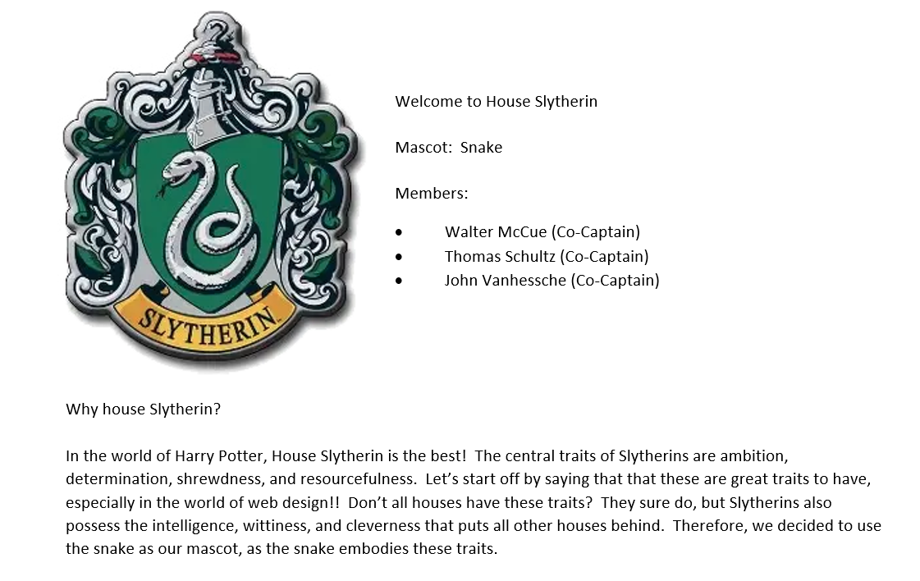

**Walter Biography**



My name is Walter McCue and I am a web developer from House Slytherin. As you can see from my photo, I love dogs. The one in this picture is my boxer/hound puppy named Rocket. When I’m home, I’m spending time with him, my wife, and our son. My hobbies include installing aftermarket lighting on cars and trucks and going to local car shows. I also enjoy Disney movies and the trending Superhero movies that have been coming out for the last few years.

Professionally, I have been in the computer and communications industries for over 15 years and am constantly attending workshops to stay up to date with modern trends in web development and user interfaces. Our world is more connected now than it has ever been and I believe that House Slytherin can make a positive impact in the local community and help connect it to the global community. That’s why I’m here and that’s why I joined this team.

**Thomas Biography**



Hello there. My name is Thomas Schultz. I’m a student at Bellevue University. I currently work at Kalmbach Media as a Web Developer. My main job to fix bugs on the site. We had a previous team work on the site and it wasn’t done properly. I also get to work on our Restful API. It’s been challenging but it’s also very rewarding. I hoping to learn new skills to help me better myself as a web developer.

On my spare time, I love spending time with my girlfriend. We have a dog named Chuck that is our favorite little buddy. I also love movies and photography. I try to see a new movie once a week. I’m also a big sports fan. I enjoy watching almost all college sports and professional teams. My favorite sports to watch live is hockey. I can’t wait to work with my team. House Slytherin hopefully wins the house cup!

**John Biography**



**Table of Contents**

SECTION 1: INTRODUCTION 2

1.1. Purpose 7

1.2. Terminology 8

1.3. User Personas 9

1.4. User Stories 12

SECTION 2: PROCESS DESIGN 13

2.1. Prototypes 13

2.2. ORD (Object Relational Diagram(s) 14

2.3. NoSQL Data Structure 15

SECTION 3: QA TESTING 16

3.1. QA Test Plan 16

3.2. Unit Tests 16

SECTION 4: REFERENCES 17

# SECTION 1: INTRODUCTION

## Purpose

**Background:**

WhatABook is a small, local used book bookstore. WhatABook would like to develop an application with the following goals in mind:

**Goals:**

* Establish an application for the bookstore to expand their online presence and add convenience for their customers.
* Allow customers to browse the stores’ inventory of books, or sort them by
  + - Genre
    - Author
    - Title
    - bookId
* Allow customers to utilize a personal wish list, where they can:
  + - Add or remove books to the wish list
    - View all the books in their wish list, or sort by:
      * Genre
      * Author
      * Title
      * bookId
    - This goal would infer that each customer has a separate “account” with the store, which would support the following additional design goals.
      * Signup process
      * Assignment of a customerId for the customer’s wish list.
      * The application should have a simple interface that panders to an older clientele with limited computer experience.

## Terminology

|  |  |
| --- | --- |
| **Name** | **Comments** |
| MEAN Stack | MongoDB, Express, Angular, and Node.js |
| VS Code | Development IDE |
| SoapUI | API testing tool |
| MongoDB Compass | Database development IDE |
| Angular Material | <https://material.angular.io/> |
| Flex-layout | <https://github.com/angular/flex-layout> |

**Core users:**

* General public:
  + - All bookstore customers (restricted account)
      * Search/browse inventory
      * Add, delete items from wish list
* Store employee:
  + - All employees (restricted account)
      * Add, delete, modify book inventory
      * Search/browse inventory
    - Bookstore Administrator (unrestricted account):
      * Add, delete, modify book inventory
      * Add, delete, modify general public by customerId and store employees
      * Add, update, delete, save, backup database and website.

## User Personas

**Persona: Customer**

Name: Bellatrix Lestrange

Age: 45

Occupation: Elementary Teacher

Hobbies: Hiking, photography,  
 spending time with family  
 and friends, baking

Favorite Genre: Sci-Fi

Favorite Author: Voldemort

Favorite Book: 2001 Space Odyssey

Likes: Spells, magic

Dislikes: Sirius Black

Goals: To be wonderful mother, wife, and someday a novelist

Biography: Bellatrix is from a big family. Like most of her family, she attended a  
 private school where she fell in love with reading. She would read anything  
 from biographies to adventures. She fell in love with sci-fi. She loved  
 traveling to a new world and exploring the dangers that could exist. She  
 hopes to get her children into reading and carry on her love of reading.

Computer Skill Level: Moderate

Needs the Application can meet: Wish list for her children and students. Hoping to book special events at Whatabook for her students.

Important Features: Login to see purchase history, wishlist, upcoming events, rewards

Unimportant Features: E-books.

Comments: Prefers physical books

**Persona: Employee**

Name: Narcissa Malfoy

Age: 32

Occupation: Receptionist

Hobbies: Cooking, long walks, spending time  
 with her cats

Favorite Genre: Crime

Favorite Author: Anne Cleeve

Favorite Book: City of Thieves

Likes: Family, reality tv, documentaries

Dislikes: Exercise, dogs, extended family

Goals: To own her own bookstore

Biography: Narcissa comes from a small town. She met her husband at an early  
 age and have one son together. Her husband owns a successful business. She  
 works at Whatabook so one day she can run her own bookstore someday.

Computer Skill Level: Expert

Needs the Application can meet: To manage inventory and help customers with  
 purchasing books in store or online.

Important Features: To manage inventory, online orders

Unimportant Features: N/A

Comments: Wants experience to help run her own store.

**Persona: Product Owner**

Name: Salazar Slytherin

Age: 45

Occupation: WhatABook Owner

Hobbies: Reading  
 Discovering new authors  
 Book Clubs

Favorite Genre: Thriller/Mystery

Favorite Author: John Grisham

Favorite Book: All Good People Here

Likes: Sorcery, Magic, Candles

Dislikes: Hufflepuff, Gryffendor, Ravenclaw

Goals: Make reading great again!

Biography: Salazar Slytherin is a 45-year-old male is the Whatabook application  
 administrator. Salazar created the bookstore for Whatabook. He is in charge  
 of modifying the inventory.

Computer Skill Level: Moderate-low

Needs the Application can meet: Inventory for his bookstore

Important Features: Being able to view wishlists to see what is trending

Unimportant Features: None

Comments: Wants a good experience for customers

## User Stories

|  |  |
| --- | --- |
| **User Stories** | **Story Points** |
| As a customer, I need to be notified when my order is ready to be picked up so I can better schedule my day. | 5 |
| As a customer, I need to be notified of upcoming releases so I know what’s new. | 8 |
| As a customer, I need to be suggested titles as I’m searching the application so I can try new books | 5 |
| As a customer, I need to be suggested ages to read books so I’m not buying books that aren’t appropriate for my children. | 5 |
| As a customer, I need to see a children’s page so I can buy books for my students. | 3 |
| As an employee, I need to be able to easily let the customer know that their order is ready so I can continue working on other tasks. | 5 |
| As an employee, I need to see more filters for searching books so I can help customers faster. | 5 |
| As an employee, I need to add the condition of the book so some customers don’t get upset when seeing the state of a used book. | 3 |
| As an employee, I need to add tags to books to better categorize them. | 5 |
| As an employee, I need to be notified when a new order comes while I’m working on the floor so I can possibly grab that item after helping another customer. | 8 |
| As a product owner, I need customers to sign up for notifications so they stay up to date with all news in regards to Whatabook. | 5 |
| As a product owner, I need customers to leave notes at check-out for any special instructions for pick-up or home delivery. | 3 |
| As a product owner, I need customers to be notified when a book on their wish list is available or lowered in price. | 5 |
| As a product owner, I need customers to be able to write reviews so other customers can see what other people are thinking about it. | 5 |
| As a product owner, I need customers to be part of a rewards program that gives them money for the online store. | 13 |

# SECTION 2: PROCESS DESIGN

## 2.1. Prototypes

<https://marvelapp.com/prototype/j40h93a>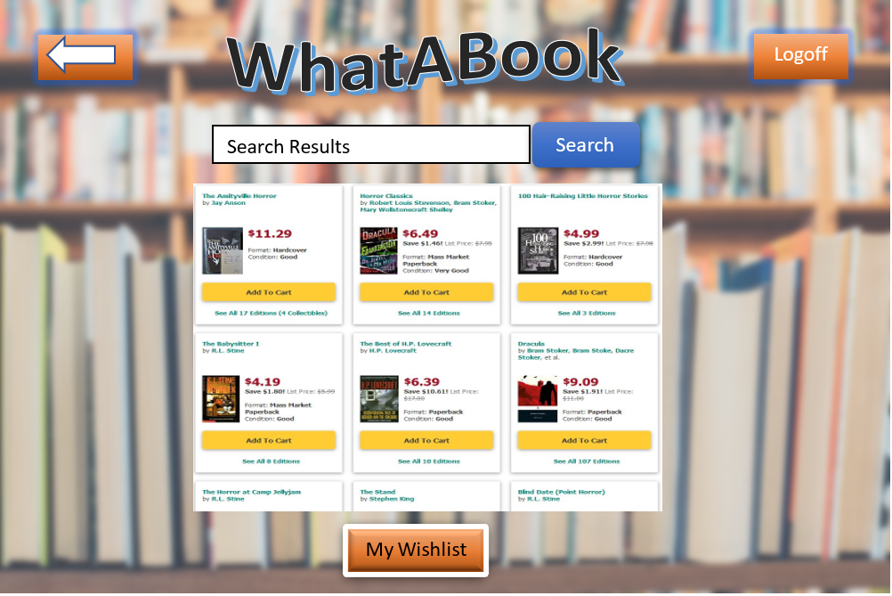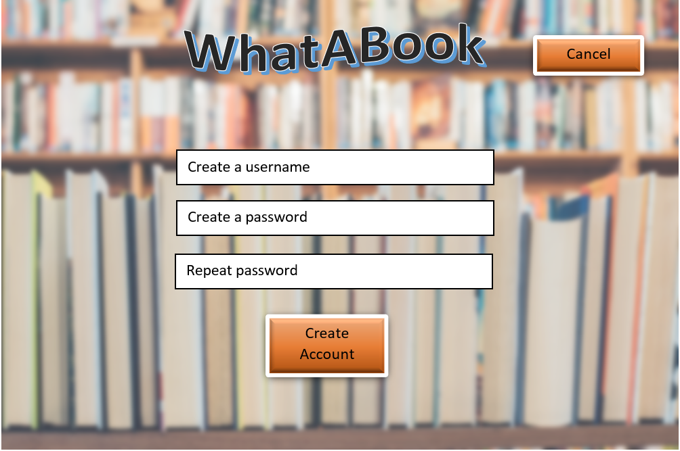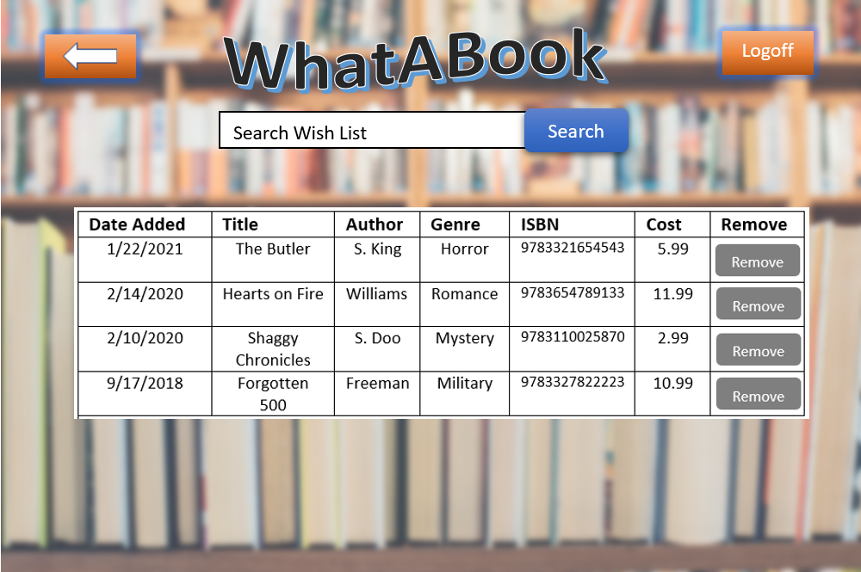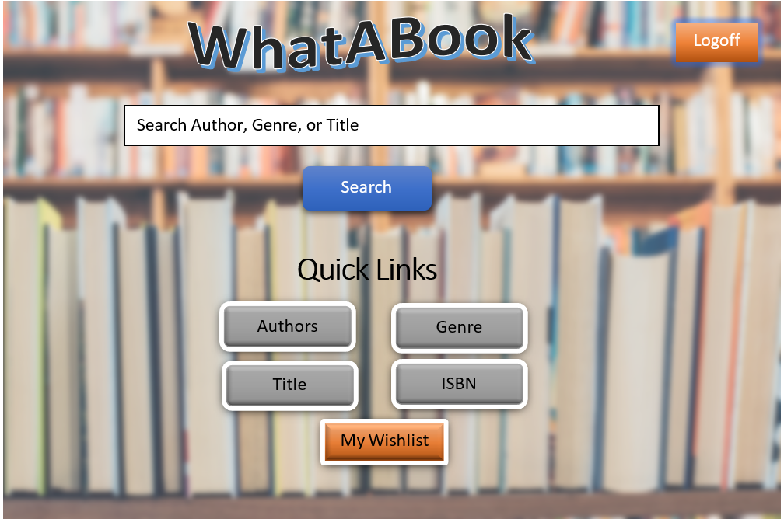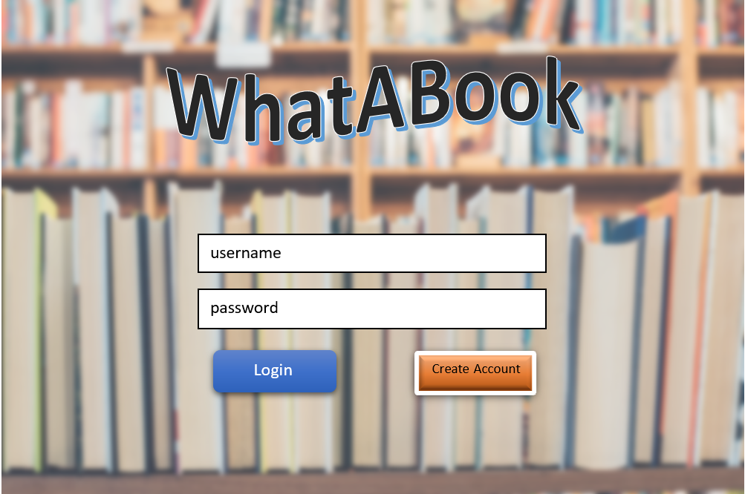



## 2.2. ORD (Object Relational Diagram(s)

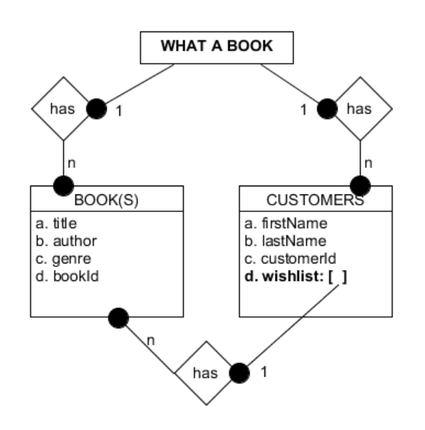

## 

## 

## 

## 

## 

## 

## 

## 2.3. NoSQL Data Structure

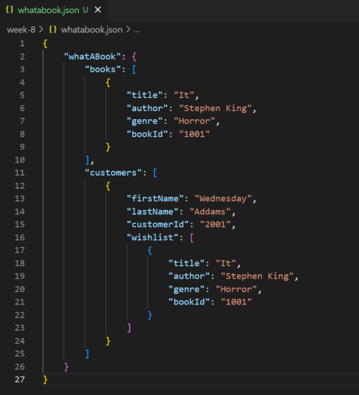

# 

# SECTION 3: QA TESTING

## 3.1. QA Test Plan

Test 1) Display a list of all books. Results of test should return ALL books in the collection.

Test 2) Display a list of books by an associated genre. Results of test should return ALL books in that genre. Genre: Thriller

Test 3) Display a list of books by an associated author. Results of test should return ALL books by that author. Author: Stephen King

Test 4) Display a list of books by an associated book id. Results of test should return ONE book with that id number. Book ID: b1013

Test 5) Display a list of books in a customer’s wish list. Results of test should return ALL books in that customers wish list. Customer ID: c1005

Test 6) Add a book to a customer’s wish list. Result of test should return an acknowledgement of an added document to the wish list array. Customer ID: c1005

Test 7) Remove a book from a customer’s wish list. Result of test should return an acknowledgement that a document was removed from the wish list array. Customer ID: c1005.

## 3.2. Unit Tests

Test 1) Display All Books

db.books.find()

[

{

_id: ObjectId("639bb5ec129979d01696ff23"),

title: 'Night Road',

author: 'Kristin Hannah',

genre: 'Thriller',

bookId: 'b1001'

},

{

_id: ObjectId("639bb5ec129979d01696ff24"),

title: 'Dark of the Moon',

author: 'John Sanford',

genre: 'Thriller',

bookId: 'b1002'

},

{

_id: ObjectId("639bb5ec129979d01696ff25"),

title: 'The Investigator',

author: 'John Sanford',

genre: 'Thriller',

bookId: 'b1003'

},

{

_id: ObjectId("639bb5ec129979d01696ff26"),

title: 'Thinner',

author: 'Richard Bachman',

genre: 'Horror',

bookId: 'b1004'

},

{

_id: ObjectId("639bb5ec129979d01696ff27"),

title: 'The Shining',

author: 'Stephen King',

genre: 'Horror',

bookId: 'b1005'

},

{

_id: ObjectId("639bb5ec129979d01696ff28"),

title: 'It',

author: 'Stephen King',

genre: 'Horror',

bookId: 'b1006'

},

{

_id: ObjectId("639bb5ec129979d01696ff29"),

title: 'The Forgotten 500',

author: 'Gregory Freeman',

genre: 'Non-Fiction',

bookId: 'b1007'

},

{

_id: ObjectId("639bb5ec129979d01696ff2a"),

title: 'Taken For A Ride',

author: 'Bradley Stertz',

genre: 'Non-Fiction',

bookId: 'b1008'

},

{

_id: ObjectId("639bb5ec129979d01696ff2b"),

title: "Before We We're Yours",

author: 'Lisa Wingate',

genre: 'Non-Fiction',

bookId: 'b1009'

},

{

_id: ObjectId("639bb5ed129979d01696ff2c"),

title: '20,000 Leagues Under The Sea',

author: 'Jules Verne',

genre: 'Fantasy',

bookId: 'b1010'

},

{

_id: ObjectId("639bb5ed129979d01696ff2d"),

title: 'The War of The Worlds',

author: 'H.G Wells',

genre: 'Fantasy',

bookId: 'b1011'

},

{

_id: ObjectId("639bb5ed129979d01696ff2e"),

title: 'The Hobbit',

author: 'J.R.R. Tolkien',

genre: 'Fantasy',

bookId: 'b1012'

},

{

_id: ObjectId("639bb5ed129979d01696ff2f"),

title: 'Getting Started With Wordpress',

author: 'Todd Kelsey',

genre: 'How-To',

bookId: 'b1013'

},

{

_id: ObjectId("639bb5ed129979d01696ff30"),

title: 'Basecamp for Beginners',

author: 'Todd Kelsey',

genre: 'How-To',

bookId: 'b1014'

},

{

_id: ObjectId("639bb5ed129979d01696ff31"),

title: 'C# Programming',

author: 'Barbara Doyle',

genre: 'How-To',

bookId: 'b1015'

}

]

===============================================================================

Test 2) Display books by genre: Thriller

db.books.find({ 'genre' : 'Thriller'})

[

{

_id: ObjectId("639bb5ec129979d01696ff23"),

title: 'Night Road',

author: 'Kristin Hannah',

genre: 'Thriller',

bookId: 'b1001'

},

{

_id: ObjectId("639bb5ec129979d01696ff24"),

title: 'Dark of the Moon',

author: 'John Sanford',

genre: 'Thriller',

bookId: 'b1002'

},

{

_id: ObjectId("639bb5ec129979d01696ff25"),

title: 'The Investigator',

author: 'John Sanford',

genre: 'Thriller',

bookId: 'b1003'

}

]

Test 3) Display books by author: Stephen King

db.books.find({ "author": 'Stephen King'})

[

{

_id: ObjectId("639bb5ec129979d01696ff27"),

title: 'The Shining',

author: 'Stephen King',

genre: 'Horror',

bookId: 'b1005'

},

{

_id: ObjectId("639bb5ec129979d01696ff28"),

title: 'It',

author: 'Stephen King',

genre: 'Horror',

bookId: 'b1006'

}

]

============================================================

Test 4) Display books by id: b1013

db.books.find({ "bookId" : 'b1013' })

[

{

_id: ObjectId("639bb5ed129979d01696ff2f"),

title: 'Getting Started With Wordpress',

author: 'Todd Kelsey',

genre: 'How-To',

bookId: 'b1013'

}

]

Test 5) Display customer wish list by id: c1005

db.customers.find({ "customerId": "c1005" }, { wishlist: 1 })

[

{

_id: ObjectId("639bb5ed129979d01696ff36"),

wishlist: [

{

title: 'The Shining',

author: 'Stephen King',

genre: 'Horror',

bookId: 'b1005'

}

]

}

]

Test 6) Add to customer wish list

db.customers.updateOne({ "customerId": "c1005" }, { $push: {"wishlist": { title: "Dark of the Moon", genre: "Thriller", author : "John Sanford", bookId: "b1002", },},})

{

acknowledged: true,

insertedId: null,

matchedCount: 1,

modifiedCount: 1,

upsertedCount: 0

}

Test 7) Remove from customer wish list

db.customers.updateOne({ "customerId": "c1005" }, { $pull: {"wishlist": { title: "Dark of the Moon", genre: "Thriller", author : "John Sanford", bookId: "b1002", },},})

{

acknowledged: true,

insertedId: null,

matchedCount: 1,

modifiedCount: 1,

upsertedCount: 0

}

# 

# SECTION 4: REFERENCES

WhatABook Requirements:

Krasso, R; WhatABook Business Requirements. Bellevue University

NoSQL/Data Models:

Sadalage, Pramod J.; Fowler, Martin. NoSQL Distilled (p. 147). Pearson Education. Kindle Edition.

<https://www.mongodb.com/docs/manual/core/data-model-design/>

Python:

<https://bellevue.mediaspace.kaltura.com/media/>

Krasso, R; MongoDB Query Guide. Bellevue University

Krasso. R; Python Guide. Bellevue University

ORD:

Krasso, R: Week 1 Presentation, WEB 335 Week 1 – Database Technologies. Bellevue University